Introduction to fractions
Donald Campbell
Summary
Fractions are a fundamental concept used to represent parts of a whole. They provide a precise way to describe values that are not whole numbers, helping you to understand the relationship between different quantities. Fractions are essential in many daily tasks, such as managing finances or using recipes, and are vital in technical fields from engineering to medicine.

What is a fraction?
A fraction is a way of showing part of a whole object. Fractions give you a way of writing numbers that do not come out as whole numbers.
Imagine you cut a pizza into eight equal slices. If you eat three slices, you have eaten
$$\frac{3}{8} \text{three eighths}$$
This means that you have eaten three out of eight slices of the whole pizza.
 Definition of a fraction
A fraction is used to represent part of a whole. It has a numerator and a denominator, and is written in the form
$$\frac{\text{numerator}}{\text{denominator}}$$
- The numerator (top number) tells you how many parts you have.
- The denominator (bottom number) tells you how many equal parts the whole is divided into.

The idea of fractions is ancient. The Egyptians used a system for fractions around 1550 BC, but they mostly used unit fractions. These are fractions with a numerator of one (like $\frac{1}{2}$ or $\frac{1}{4}$). Indian and Arabic mathematicians developed the modern style used today, where fractions are written with a numerator on top of a denominator separated by a bar.
In the pizza example, the numerator is the three pizza slices eaten, and the denominator is the eight equal parts the whole pizza is divided into.
Below are pizzas each divided into eight slices. In each case, the number of shaded slices corresponds to the numerator and the total number of slices corresponds to the denominator.
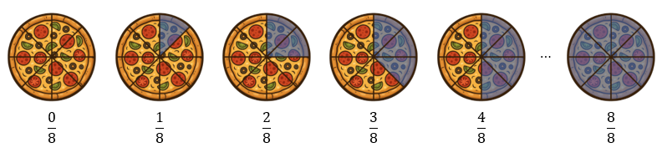
Fractions represented by shaded slices of a pizza.
 Tip
You can think of a fraction as:
$$\frac{\text{numerator}}{\text{denominator}}=\frac{\text{"number you have"}}{\text{"number in total"}}$$

Example 1
You cannot avoid fractions! They are used all the time.
- Suppose a recipe asks for one quarter of a kilogram of flour. If you do not use fractions and guess, you might add a whole cup more, making your cake dry and crumbly!
- If 5 units of currency is split evenly between four people, each person gets a quarter of 5 which is 1.25. If you do not use fractions and guess, some of your friends might be unhappy!
- If your boss says “I will meet you here in quarter of an hour”, they are using a fraction. They mean they are expecting you to arrive in 15 minutes. This would be impossible to work out without fractions!
Fractions are different from whole numbers as whole numbers are numbers which have no fractional part. In fractions, you get a whole number when the numerator can be perfectly divided by the denominator with no remainder. The horizontal bar that separates the numerator and the denominator is another way of saying division. When talking about fractions, a whole number is typically referred to as a whole.
$$\frac{8}{8}=1 \frac{12}{4}=3 \frac{24}{4}=6$$
Tip
Any fraction for which the numerator is the same as the denominator is equivalent to one whole.

Types of fractions
So far, you have seen how fractions represent parts of a single whole. But what happens when you have more than one whole, such as one full pizza and an extra slice? To handle amounts that are less than one, you can use proper fractions. But if you want to handle amounts which are greater than one, there are two different types of fractions you can use; improper fractions or mixed numbers.
$$\begin{matrix}\frac{3}{8} \\ \text{three eighths} \\ \text{proper fraction}\end{matrix} \begin{matrix}\frac{7}{4} \\ \text{seven quarters} \\ \text{improper fraction}\end{matrix} \begin{matrix}1\frac{3}{4} \\ \text{one and three quarters} \\ \text{mixed number}\end{matrix}$$
In each case, there is a different relationship between the numerator and the denominator. These differences are what define the three main types of fractions.
Types of fractions
There are three types of fractions.
- Proper fraction: A fraction where the numerator is less than the denominator.
- Improper fraction: A fraction where the numerator is greater than or equal to the denominator.
- Mixed number: A whole number and a proper fraction together.
An improper fraction is also known as a “top-heavy” fraction.

How does this compare to the examples from before?
- The fraction $\frac{3}{8}$ is a proper fraction as the numerator $3$ is less than the denominator $8$.
- The fraction $\frac{7}{4}$ is an improper fraction as the numerator $7$ is greater than or equal to the denominator $4$.
- The fraction $1\frac{3}{4}$ is a mixed number as it consists of a whole number $1$ and a proper fraction $\frac{3}{4}$.
Example 2
Below are some more examples of proper fractions, improper fractions and mixed numbers.
$$\begin{matrix}\text{Proper fractions:} & \frac{1}{4} \frac{1}{2} \frac{14}{25} \\ \text{Improper fractions:} & \frac{7}{4} \frac{5}{2} \frac{27}{25} \frac{2}{2} \\ \text{Mixed numbers:} & 1\frac{3}{4} 2\frac{1}{2} 1\frac{2}{25}\end{matrix}$$

 Important
You can notice that all the proper fractions are less than one whole, and that all the improper fractions are greater than or equal to one whole. This is what distinguishes these two types of fractions from each other.

The number line below shows that fractions are numbers between whole numbers. This example illustrates the equivalence between improper fractions and mixed numbers. The red dot is placed at $\frac{7}{4}$, which is the same value as $1\frac{3}{4}$.
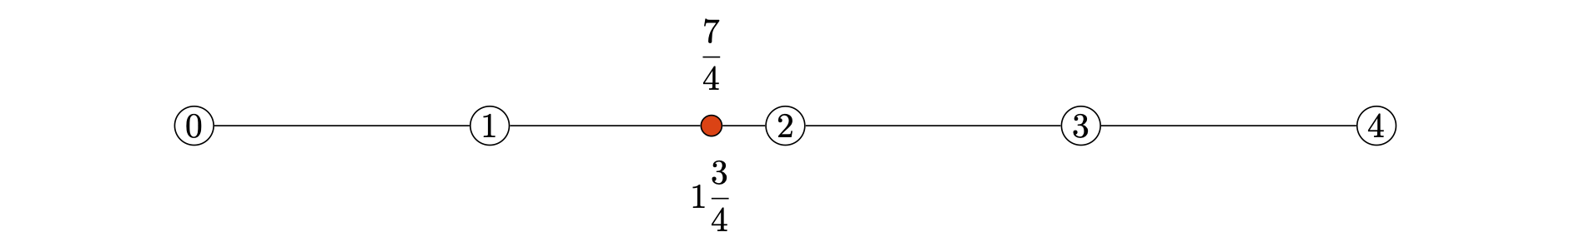
A number line showing the equivalence of the improper fraction $\frac{7}{4}$ and the mixed number $1\frac{3}{4}$.

Converting between improper fractions and mixed numbers
As the number line illustrates, improper fractions and mixed numbers are equivalent forms of each other. There is a rule that you can follow to convert between them.
Converting between improper fractions and mixed numbers
To convert an improper fraction into a mixed number:
- Divide the numerator by the denominator.
- Write the whole number part of your answer first.
- Write the remainder over the same denominator for the fractional part of your answer.
To convert a mixed number into an improper fraction:
- Multiply the whole number part by the denominator.
- Add the numerator.
- Write this total over the same denominator.

Example 3
Write $\frac{11}{4}$ as a mixed number.
Start by dividing the numerator $11$ by the denominator $4$ to get $2$ remainder $3$. Write the whole number part $2$ first, then write the remainder $3$ over the denominator $4$ as the fractional part.
$$\frac{11}{4}=2\frac{3}{4}$$

Example 4
Write $3\frac{2}{5}$ as an improper fraction.
Start by multiplying the whole number $3$ by the denominator $5$ to get $15$. Then, add the numerator $2$ to get $17$. Write this total over the same denominator $5$.
$$3\frac{2}{5}=\frac{17}{5}$$
Below are three circles, each divided into equal parts. The shaded parts show how an improper fraction can be converted into a mixed number, represented by whole circles and any extra shaded parts.
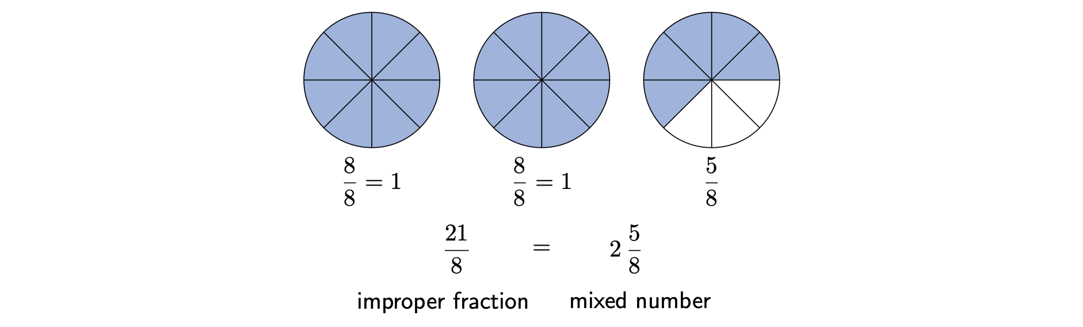
Improper fractions and mixed numbers represented by shaded parts of three circles.

Equivalent fractions
Two fractions are called equivalent if they represent the same value, even though they have different numerators and denominators.
Imagine you’re back to eating pizza. Eating two slices out of a total of four is the same as eating four slices out of a total of eight, as you have eaten one half of the whole pizza in both cases.
This means that the two fractions are equivalent:
$$\frac{2}{4}=\frac{4}{8}$$
But why are they the same? Notice that to get from $\frac{2}{4}$ to $\frac{4}{8}$, you need to multiply both the numerator and the denominator by two.
Creating equivalent fractions
To create an equivalent fraction, multiply or divide both the numerator and the denominator by the same non-zero number. What you do to the top must be done to the bottom.

Example 5
Find an equivalent fraction for $\frac{2}{3}$.
To find an equivalent fraction, you need to multiply the top and bottom by any non-zero number, say five.
$$\frac{2}{3}=\frac{2⋅5}{3⋅5}=\frac{10}{15}$$
This means $\frac{2}{3}$ and $\frac{10}{15}$ are equivalent fractions.
The figure below shows a fraction wall, a tool used to visualize equivalent fractions. Each row represents one whole, divided into equal parts corresponding to the denominator. Fractions that are equivalent (represent the same amount) align vertically.
For example, if you look at the line for $\frac{1}{2}$, you can see it lines up perfectly with the end of:
- two $\frac{1}{4}$ blocks (showing $\frac{1}{2}=\frac{2}{4}$)
- three $\frac{1}{6}$ blocks (showing $\frac{1}{2}=\frac{3}{6}$)
- four $\frac{1}{8}$ blocks (showing $\frac{1}{2}=\frac{4}{8}$)
- five $\frac{1}{10}$ blocks (showing $\frac{1}{2}=\frac{5}{10}$)
- six $\frac{1}{12}$ blocks (showing $\frac{1}{2}=\frac{6}{12}$)
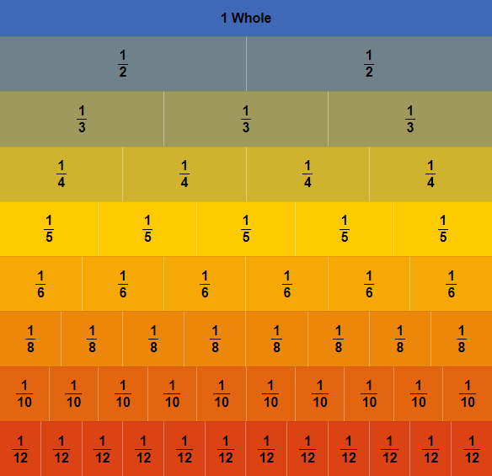
A fraction wall showing equivalent fractions.
Example 6
Below are some more examples of equivalent fractions. The fractions in each row are all equivalent to each other.
$$\begin{matrix} & \frac{1}{2}=\frac{2}{4}=\frac{3}{6}=\frac{25}{50} \\ & \frac{1}{3}=\frac{2}{6}=\frac{3}{9}=\frac{25}{75} \\ & \frac{5}{6}=\frac{10}{12}=\frac{15}{18}=\frac{250}{300}\end{matrix}$$
The figure below illustrates the concept of equivalent fractions. The circle on the left is divided into four equal parts, with two shaded, representing the fraction $\frac{2}{4}$. The circle on the right is divided into twelve smaller parts, with six shaded, representing the fraction $\frac{6}{12}$. Since the shaded area is the same for both circles, this visually demonstrates that the two fractions are equivalent.

Equivalent fractions represented by shaded parts of two circles.
Important
The concept of equivalent fractions also applies to negative fractions. A single negative sign can be placed with the numerator, the denominator, or in front of the entire fraction, and the value remains the same.
For example, all three of these forms represent the same value:
$$−\frac{3}{5}=\frac{−3}{5}=\frac{3}{−5}$$
By convention, it is most common to place the sign in front of the fraction, like $−\frac{3}{5}$.
Also, positive fractions are equivalent to fractions with a negative numerator and a negative denominator as the multiplier is $−1$.
$$\frac{3}{5}\overset{×−1}{=}\frac{−3}{−5}$$

Finding equivalent fractions is necessary for comparing fractions, performing calculations with fractions, and developing good habits for later topics such as those explored in Guide: Arithmetic on numerical fractions, Guide: Introduction to algebraic fractions and Guide: Arithmetic on algebraic fractions. They are particularly helpful when you need to add together two fractions with different denominators.
The case of dividing the numerator and the denominator by the same number to find an equivalent fraction has a specific name. This is the topic of the next section.

Simplifying fractions
In the previous section, you saw how to create equivalent fractions by multiplying the numerator and the denominator by the same number, such as changing $\frac{2}{3}$ into $\frac{10}{15}$. You can also go in the other direction. The process of dividing both the numerator and the denominator by the same number is called simplifying.
Simplifying is how you find the lowest terms version of a fraction. In the pizza example, $\frac{2}{4}$ is equivalent to $\frac{1}{2}$. Simplifying is the formal process for getting from $\frac{2}{4}$ back to $\frac{1}{2}$.
$$\frac{2}{4}=\frac{2÷2}{4÷2}=\frac{1}{2}$$
To simplify fractions, it is important to know what is meant by common factors and, in particular, the highest common factor.
Factors, common factors, and the highest common factor
A factor is a whole number that divides exactly into another number, leaving no remainder.
When comparing the factors of two (or more) numbers, you can find their common factors. The numbers that appear in both lists of factors are the common factors.
The highest common factor is the largest number in the list of common factors.
To find the highest common factor:
- List all the factors of the first number.
- List all the factors of the second number.
- Identify all the common factors (the numbers that appear in both lists).
- The largest of these common factors is the highest common factor.

Example 7
Find the highest common factor of $20$ and $30$.
Start by identifying the factors of $20$. These are the whole numbers that divide exactly into $20$, leaving no remainder.
$$\text{Factors of }20\text{:} 1 2 4 5 10 20$$
Now identify the factors of $30$. These are the whole numbers that divide exactly into $30$, leaving no remainder.
$$\text{Factors of }30\text{:} 1 2 3 5 6 10 15 30$$
The numbers that appear in both lists are the common factors.
$$\text{Common factors:} 1 2 5 10$$
The largest number appearing in this list of common factors is the highest common factor.
$$\text{Highest common factor:} 10$$
Common factors are used in the process of determining whether a fraction is fully simplified or not. The method for fully simplifying a fraction depends on finding the highest common factor.
Simplifying fractions
A fraction is fully simplified, in its simplest form, or in its lowest terms when its numerator and denominator have no common factors other than one.
To fully simplify a fraction that is not already in its simplest form, divide the numerator and the denominator by its highest common factor.

Example 8
Write $\frac{12}{18}$ in its simplest form.
Start by identifying the factors of both the numerator $12$ and the denominator $18$.
$$\begin{matrix}\text{Factors of }12\text{:} & 1 2 3 4 6 12 \\ \text{Factors of }18\text{:} & 1 2 3 6 9 18 \\ \text{Common factors:} & 1 2 3 6 \\ \text{Highest common factor:} & 6\end{matrix}$$
The highest common factor is $6$, so divide the numerator and the denominator by $6$.
$$\frac{12}{18}=\frac{12÷6}{18÷6}=\frac{2}{3}$$
Therefore, the fraction $\frac{12}{18}$ can be written in its simplest form as $\frac{2}{3}$.
Not all fractions can be simplified as some may already be written in their simplest form.
Example 9
Consider the fraction $\frac{7}{20}$.
Start by identifying the factors of both the numerator $7$ and the denominator $20$.
$$\begin{matrix}\text{Factors of }7\text{:} & 1 7 \\ \text{Factors of }20\text{:} & 1 2 4 5 10 20 \\ \text{Common factors:} & 1\end{matrix}$$
Since the numerator and the denominator have no common factors other than $1$, the fraction is already in its simplest form.
The figure below demonstrates how to simplify a fraction. The circle on the left represents the original fraction $\frac{15}{20}$. The circle on the right shows the equivalent simplified fraction $\frac{3}{4}$. Both circles have the same amount shaded, showing they represent the same value.

The process of simplifying fractions, represented by shaded parts of two circles.
To simplify $\frac{15}{20}$, you need to find the highest common factor of the numerator $15$ and the denominator $20$, which is $5$. Then, divide both the numerator and the denominator by this highest common factor.
$$\frac{15}{20}=\frac{15÷5}{20÷5}=\frac{3}{4}$$
This gives the fraction in its simplest form.
Tip
All unit fractions (fractions where the numerator is one) are already in their simplest form as there are no common factors other than one.

Important
When both the numerator and the denominator of a fraction are negative, the negative signs cancel each other out through the simplifying process, resulting in an equivalent positive fraction. This is because you can divide the numerator and denominator by their common factor of $−1$.
$$\frac{−3}{−5}=\frac{−3÷−1}{−5÷−1}=\frac{3}{5}$$

 Warning
A common mistake is stopping before fully simplifying, such as simplifying $\frac{12}{24}$ to $\frac{6}{12}$ instead of $\frac{1}{2}$.
This comes about when you simplify using a common factor that is not the highest common factor. In this case, the common factors of $12$ and $24$ are $1$, $2$, $3$, $4$, $6$ and $12$. The highest common factor is $12$, but the common factor $2$ was used for simplifying instead.
Choosing any of the common factors to simplify by is still an acceptable method that you may prefer to use over this method, but it means that you need to simplify more than once to get to the simplest form of the original fraction.

It is good practice to simplify fractions whenever possible. It will be particularly useful for later topics such as those explored in Guide: Arithmetic on numerical fractions, Guide: Introduction to algebraic fractions and Guide: Arithmetic on algebraic fractions.

Quick check problems
- In the fraction $\frac{7}{10}$, what is the number $10$ called?
- numerator
- denominator
- quotient
- dividend
- If a chocolate bar is divided into $7$ equal squares and you eat $5$ of them, what fraction of the bar have you eaten?
- What type of fraction is $\frac{12}{5}$?
- proper fraction
- improper fraction
- mixed number
- Convert $2\frac{1}{3}$ into an improper fraction.
- Which of the following fractions is equivalent to $\frac{2}{5}$?
- $\frac{5}{2}$
- $\frac{4}{5}$
- $\frac{4}{10}$
- $\frac{2}{10}$
- Write the fraction $\frac{9}{12}$ in its simplest form.

Further reading
For more questions on the subject, please go to Questions: Introduction to fractions.
To learn how to perform arithmetic on numerical fractions, please see Guide: Arithmetic on numerical fractions.

Version history
v1.0: initial version created 12/25 by Donald Campbell as part of a University of St Andrews VIP project.
This work is licensed under CC BY-NC-SA 4.0.

