Arithmetic with fractions
Donald Campbell
Summary
Arithmetic with fractions involves combining, comparing, and scaling parts of a whole through addition, subtraction, multiplication, and division. Mastering these operations on fractions is essential, as these operations are widely used in everyday situations such as cooking, construction, finance, science, or in any application where quantities must be measured, divided, or compared accurately.
Before reading this guide, it is recommended that you read Guide: Introduction to fractions.
In Guide: Introduction to fractions, you saw that a fraction represents part of a whole, and that it consists of a numerator and a denominator. This guide explains how to add, subtract, multiply and divide fractions. It explores the reasoning and methods behind applying these four main arithmetic operations, showing how the core concepts of fractions can be extended to calculations.

Adding and subtracting fractions
Imagine you have two equal-sized chocolate bars. One bar is split into four equal parts and you eat one piece. This means that $\frac{1}{4}$ of the first bar has been eaten. Suppose the other bar is split into six equal parts and you eat a piece, which means that $\frac{1}{6}$ of the second bar has been eaten.
Therefore, the total amount of chocolate bar that you have eaten is
$$\frac{1}{4}+\frac{1}{6}.$$
At first glance, it might seem natural to add the numerators and the denominators separately, but this would give $\frac{2}{10}$, which is incorrect. The reason for this is that the parts being added are not the same because they are not the same size; quarters and sixths are different-sized pieces of a whole. This leads into the golden rule of adding and subtracting things:
 Golden rule of adding/subtracting fractions
You can only add or subtract things that are the same.
So to add or subtract fractions fairly, the parts being combined must be the same size.

If both bars are divided into twelve equal parts, equivalent fractions can be found for the amounts eaten from both bars. For more on finding equivalent fractions, please see Guide: Introduction to fractions.
$$\begin{matrix} & \frac{1}{4}\overset{×3}{=}\frac{3}{12} \\ & \frac{1}{6}\overset{×2}{=}\frac{2}{12}\end{matrix}$$
Both fractions now share the same denominator, meaning the pieces scoffed from each bar are the same size. You can now add both pieces of chocolate together to get
$$\frac{1}{4}+\frac{1}{6}=\frac{3}{12}+\frac{2}{12}=\frac{5}{12}$$
 Adding and subtracting fractions
To add or subtract fractions, the denominators of both fractions must be the same according to the golden rule above.
- If the fractions already have the same denominator, add or subtract the numerators and keep the same denominator.
- If the fractions have different denominators, rewrite them as equivalent fractions so that the two new fractions have the same denominator. Then, add or subtract the numerators and keep the same denominator.

Example 1
Calculate $\frac{2}{7}+\frac{3}{7}$.
The fractions have the same denominator so they can be added directly.
So you can add the numerators and keep the same denominator to get
$$\frac{2}{7}+\frac{3}{7}=\frac{2+3}{7}=\frac{5}{7}$$
You should always look to see if the fraction can be simplified further. In this case, there are no common factors other than $1$ so the fraction is already in its simplest form.
To add or subtract fractions with different denominators, you must first find a common denominator. A common denominator is a number that can be evenly divided by both of the original denominators.
A common denominator can always be found by multiplying the two denominators together. For example, for $\frac{1}{4}$ and $\frac{1}{6}$, you could use $4⋅6=24$ as a common denominator.
But in the example above, $12$ was used as the common denominator. Why can you use this number?
The problem is that multiplying the denominators can often result in working with very large numbers, especially when it comes to simplifying the resulting fraction. A more reliable method is to find the lowest common multiple of the denominators. (It’s important to note that the lowest common multiple is not the same thing as the highest common factor from Guide: Introduction to fractions.)
Multiples, common multiples, and the lowest common multiple
A multiple of a number is the result of multiplying that number by any whole number.
When comparing the multiples of two (or more) numbers, you can find their common multiples. The numbers that appear in both lists of multiples are the common multiples.
The lowest common multiple is the smallest positive number in the list of common multiples.
To find the lowest common multiple:
- List the first few multiples of the first number.
- List the first few multiples of the second number.
- Identify the common multiples (the numbers that appear in both lists).
- The smallest of these common multiples is the lowest common multiple.
If you do not find any common multiples in your initial lists, then extend them by listing more multiples until you find a match.
You can also find the lowest common multiple by multiplying the two numbers together and dividing by their highest common factor.

Example 2
Find the lowest common multiple of $4$ and $6$.
Start by identifying the first few multiples of $4$. These are the numbers that are the result of multiplying $4$ by any whole number.
$$\text{Multiples of }4\text{:} 4 8 12 16 20 24 ⋯$$
Now identify the first few multiples of $6$. These are the numbers that are the result of multiplying $6$ by any whole number.
$$\text{Multiples of }6\text{:} 6 12 18 24 30 36 ⋯$$
The numbers that appear in both lists are the common multiples.
$$\text{Common multiples:} 12 24 ⋯$$
The smallest number appearing in this list of common multiples is the lowest common multiple.
$$\text{lowest common multiple:} 12$$

 Tip
If you would like to check your answers for the lowest common multiple of two integers, you can use our calculator at Calculator: Highest common factor, lowest common multiple.

Using the lowest common multiple provides the smallest denominator, which reduces the chances of errors in the final simplifying step.
This smallest value is also called the lowest common denominator. For the example of the chocolate bars, the lowest common denominator is $12$. The numerators of the original fractions must also be scaled to ensure the fractions remain equivalent.
Example 3
Calculate $\frac{1}{2}−\frac{5}{6}$.
The fractions have different denominators so they cannot be subtracted directly. You will then need to find the lowest common denominator.
You can start by identifying the multiples of the denominators $2$ and $6$.
$$\begin{matrix}\text{Multiples of }2\text{:} & 2 4 6 8 10 12 ⋯ \\ \text{Multiples of }6\text{:} & 6 12 18 ⋯ \\ \text{Common multiples:} & 6 12 ⋯ \\ \text{lowest common multiple:} & 6\end{matrix}$$
The lowest common multiple is $6$, so you can rewrite both fractions so that they both have a denominator of $6$.
$$\begin{matrix} & \frac{1}{2}\overset{×3}{=}\frac{3}{6} \\ & \frac{5}{6}\overset{×1}{=}\frac{5}{6}\end{matrix}$$
Now that both fractions have the same denominator, you can now subtract the numerators.
$$\frac{3}{6}−\frac{5}{6}=\frac{3−5}{6}=\frac{−2}{6}$$
Simplifying the fraction gives
$$\frac{1}{2}−\frac{5}{6}=\frac{−2}{6}=\frac{−1}{3}=−\frac{1}{3}$$
and this is your final answer.
The figure below provides a visual representation of adding $\frac{4}{5}$ (blue) and $\frac{3}{8}$ (red). It uses shaded rectangular bars to show the original fractions on the left, their conversion to a common denominator $40$ in the middle, and the final sum of $1\frac{7}{40}$ on the right.
$$\frac{4}{5}+\frac{3}{8}=\frac{32}{40}+\frac{15}{40}=\frac{47}{40}=1\frac{7}{40}$$
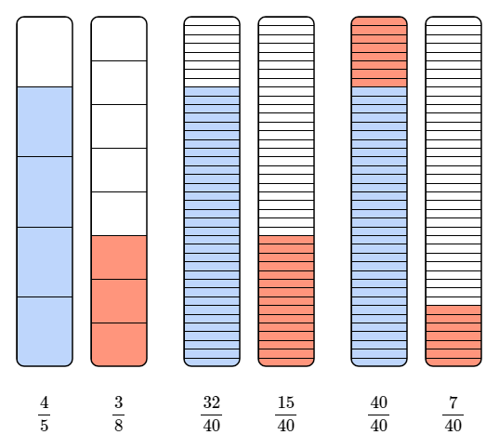
Addition of fractions represented by shaded regions of rectangular bars and equivalent fractions.

Multiplying fractions
Multiplying fractions means finding a fraction of another fraction.
$$\frac{1}{2}⋅\frac{1}{3} \text{"a half of a third"}$$
When you multiply two fractions that are both less than $1$, the result is smaller than both of the original fractions because you are taking a part of a part. This is different from multiplying whole numbers greater than $1$, where multiplying makes numbers bigger.
Imagine you have yet another delicious chocolate bar – probably from Cantor’s Confectionery. Suppose you divide it vertically into three equal parts (thirds) and cover the first part so that $\frac{1}{3}$ of the bar is covered. Suppose you now divide the same bar horizontally into two equal parts (halves) and cover the first part so that $\frac{1}{2}$ of the bar is covered. The overlapping section shows the part that is both a half and a third at the same time. It covers one out of six equal parts of the bar.
$$\frac{1}{2}⋅\frac{1}{3}=\frac{1}{6}$$
This is why multiplying fractions means taking one fraction of another.
Multiplying fractions
To multiply two fractions together:
- Multiply the numerators together and write this as the new numerator.
- Multiply the denominators together and write this as the new denominator.
- Simplify the result, if possible.

Unlike with addition or subtraction, you do not need to find a common denominator when multiplying fractions. Each fraction acts as its own scaling; for instance, multiplying by $\frac{1}{2}$ means “take one half of”, and multiplying by $\frac{1}{3}$ means “take one third of”. If both fractions are less than $1$, each denominator divides the quantity again, so the number gets smaller.
Example 4
Calculate $\frac{3}{4}⋅\frac{8}{9}$.
Multiply the numerators and the denominators separately, and simplify the result.
$$\frac{3}{4}⋅\frac{8}{9}=\frac{3⋅8}{4⋅9}=\frac{24}{36}=\frac{2}{3}$$
In this example, the numerators and the denominators of the fraction $\frac{24}{36}$ are small enough to make simplifying manageable. When the numbers are larger, multiplying first can create very large numbers on the numerator and the denominator.
A more reliable method is to simplify before multiplying. You can do this by cancelling any common factors between any numerator and any denominator in the problem.
Example 5
Calculate $\frac{14}{25}⋅\frac{15}{21}$.
The previous method involved multiplying first and then simplifying.
$$\frac{14}{25}⋅\frac{15}{21}=\frac{14⋅15}{25⋅21}=\frac{210}{525}$$
This is a large fraction which takes a while to simplify. You would need to find the highest common factor of these two numbers (which is $105$) or simplify in multiple steps (divide by $5$, then $7$, then $3$). Here,
$$\frac{210}{525}=\frac{210÷105}{525÷105}=\frac{2}{5}$$
and this is your final answers.
There is a more reliable method to perform this multiplication by looking for common factors in both numerators and denominators.
Example 6
Calculate $\frac{14}{25}⋅\frac{15}{21}$.
Here, you can see
- The numerator $14$ and the denominator $21$ share a common factor of $7$.
- The numerator $15$ and the denominator $25$ share a common factor of $5$.
You can show this cancelling process directly on the fractions. First, divide $14$ and $21$ by their common factor of $7$ to get $2$ and $3$, respectively. Next, divide $15$ and $25$ by their common factor of $5$ to get $3$ and $5$, respectively.
The original problem has now become:
$$\frac{2}{5}⋅\frac{3}{3}$$
Notice that $3$ is also a common factor in a numerator and denominator so the final simplified multiplication problem is:
$$\frac{2}{5}⋅\frac{1}{1}$$
You can now multiply the simplified numerators together and the simplified denominators together, as before
$$\frac{2}{5}⋅\frac{1}{1}=\frac{2⋅1}{5⋅1}=\frac{2}{5}$$
This method gives the final simplified answer directly and avoids large calculations.

 Warning
This method of cancelling factors only works for multiplication. You cannot cancel factors across numerators and denominators when adding or subtracting fractions.

The figures below provide a visual representation of multiplying $\frac{5}{11}$ (blue) and $\frac{3}{5}$ (red). The figure on the left shows $\frac{5}{11}$ as $5$ shaded columns out of $11$. The figure in the middle shows $\frac{3}{5}$ as $3$ shaded rows out of $5$. The figure on the right overlays these two grids, creating a new $11×5$ grid of $55$ total squares. The overlapping (pink) area contains $5⋅3=15$ squares, visually demonstrating the multiplication result $\frac{15}{55}$.
$$\frac{5}{11}⋅\frac{3}{5}=\frac{1}{11}⋅\frac{3}{1}=\frac{1⋅3}{11⋅1}=\frac{3}{11}$$
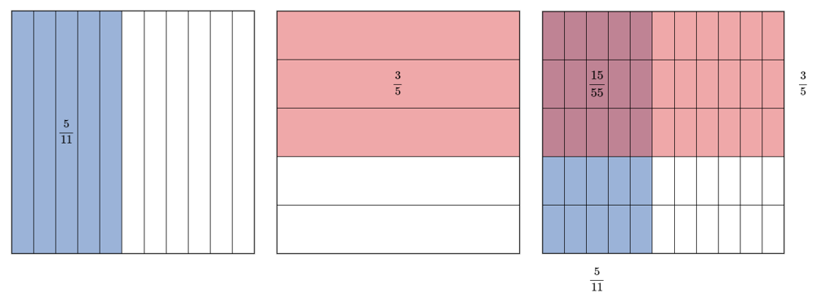
Multiplication of fractions $\frac{5}{11}$ and $\frac{3}{5}$ represented by overlapping shaded grids.
If you want to multiply a fraction by a whole number, you can rewrite the whole number as an improper fraction with denominator 1, then multiply. For example,
$$\frac{3}{5}⋅6=\frac{3}{5}⋅\frac{6}{1}=\frac{3⋅6}{5⋅1}=\frac{18}{5}=3\frac{3}{5}$$

Dividing fractions
Whenever you are dividing one fraction by another fraction, you are asking yourself the question “How many times does this fraction fit into the other?”
The process for dividing fractions is similar to the process for multiplying fractions, with one key change: dividing by a fraction is the same as multiplying by the reciprocal of that fraction.
Reciprocal of a fraction
The reciprocal of a fraction is what you get by swapping its numerator and denominator.
For example, the reciprocal of $\frac{5}{7}$ is $\frac{7}{5}$.

So, instead of working directly with division, you can rewrite the question as a multiplication problem, which you know how to do.
Imagine you have $\frac{2}{3}$ of a chocolate bar, and you want to know how many pieces of size $\frac{5}{7}$ fit inside that amount. Instead of trying to figure out how many times $\frac{5}{7}$ fits into $\frac{2}{3}$, you can flip $\frac{5}{7}$ to get its reciprocal $\frac{7}{5}$ and then turn the division into multiplication.
$$\frac{2}{3}÷\frac{5}{7}=\frac{2}{3}⋅\frac{7}{5}$$
Dividing fractions
To divide fractions, you can follow the keep, change, flip method:
- Keep the first fraction the same.
- Change division to multiplication.
- Flip the second fraction (take its reciprocal).
This turns the division problem into a multiplication problem, which you know how to do!

Example 7
Calculate $\frac{3}{4}÷\frac{1}{8}$.
To do this, you could follow the keep, change, flip method.
Keep the first fraction as $\frac{3}{4}$, change the division sign to a multiplication sign, and flip the second fraction so that $\frac{1}{8}$ becomes $\frac{8}{1}$. Now multiply the fractions together.
$$\frac{3}{4}÷\frac{1}{8}=\frac{3}{4}⋅\frac{8}{1}=\frac{3}{1}⋅\frac{2}{1}=\frac{3⋅2}{1⋅1}=\frac{6}{1}=6$$
As seen in the multiplying fractions section, when you multiply two fractions that are both less than $1$, the result gets smaller because you are taking a fraction of a fraction. Dividing by fractions works differently. When you divide by a fraction, you are asking how many of those smaller pieces fit into what you already have. This means that the answer could actually be larger than the number you started with.

Arithmetic with mixed numbers
When doing arithmetic on mixed numbers, the safest way to do this is to convert to improper fractions (as seen in Guide: Introduction to fractions and then use the processes above.
Example 8
Calculate $1\frac{2}{3}+\frac{4}{5}$.
Here, you should first convert the mixed number $1\frac{2}{3}$ into an improper fraction to get
$$1\frac{2}{3}=\frac{5}{3}$$
which turns into the sum
$$\frac{5}{3}+\frac{4}{5}$$
You can notice that they have different denominators, and so you need to find a common denominator. Since $3×5=15$, and $15$ is not too big, this will do. (You can work this out as the lowest common multiple of $3$ and $5$ as well.) So
$$\begin{matrix} & \frac{5}{3}\overset{×5}{=}\frac{25}{15} \\ & \frac{4}{5}\overset{×3}{=}\frac{12}{15}\end{matrix}$$
This means that
$$\begin{matrix}1\frac{2}{3}+\frac{4}{5}=\frac{5}{3}+\frac{4}{5}=\frac{25}{15}+\frac{12}{15}=\frac{37}{15}\end{matrix}$$
and if you want to, you can write this final answer as the mixed number $2\frac{7}{15}$.

Quick check problems
- Calculate $\frac{1}{5}+\frac{2}{5}$.
- What is the lowest common multiple of $6$ and $10$?
- Calculate $\frac{1}{2}+\frac{1}{4}$.
- Calculate $\frac{1}{3}−\frac{1}{2}$.
- Calculate $\frac{1}{2}⋅\frac{3}{4}$.
- Calculate $\frac{1}{2}÷\frac{1}{4}$.

Further reading
For more questions on the subject, please go to Questions: Arithmetic on numerical fractions.
To learn about fractions which include algebraic terms, please see Guide: Introduction to algebraic fractions.

Version history
v1.0: initial version created 12/25 by Donald Campbell as part of a University of St Andrews VIP project.
This work is licensed under CC BY-NC-SA 4.0.

