Arithmetic on complex numbers
Charlotte McCarthy
Summary
Doing arithmetic using complex numbers is a core concept in mathematics as it allows you to perform calculations in the complex plane. This guide covers addition, subtraction, multiplication, and division on complex numbers.
Before reading this guide, it is recommended that you read Guide: Introduction to complex numbers.

Introduction
In Guide: Introduction to complex numbers, you learned that complex numbers help you solve equations such as $x^{2}=−1$ by introducing the imaginary unit $i$.
However, what should you do if you want to add together or divide two or more different complex numbers?
Arithmetic on real numbers underpins almost every aspect of life. Since the complex numbers extend the real numbers, it is natural to ask how arithmetic operations work on complex numbers. It turns out that this type of arithmetic is a powerful tool used to solve a variety of problems across mathematics, physics, engineering, and computer science. It can be used to solve problems relating to fluid dynamics, oscillations, computer graphics, and many more!
Understanding how to do arithmetic using complex numbers allows you to perform operations - addition, subtraction, multiplication, and division - providing a framework for studying electrical circuits, wave behaviour and even quantum mechanics.
This guide will focus on how to perform these operations: starting with addition and subtraction, moving on to multiplication, then division, and finishing with quick-check questions at the end where you can test yourself. Throughout, Argand diagrams (see Guide: Introduction to complex numbers for further information) are used to visualize complex numbers.
 Important
Throughout the guide, complex numbers are written as $z=a+bi$ where $a$ and $b$ are real numbers known as the real and imaginary parts of $z$.

Addition and subtraction
In Guide: Introduction to complex numbers, you learned that a complex number has both a real part and an imaginary part. When you want to add or subtract complex numbers you should add/subtract the real parts and add/subtract the imaginary parts.
If you want to calculate $z+w$ then you could use this general form:
$$z+w=\left(a+bi\right)+\left(c+di\right)$$
and removing the brackets gives
$$z+w=a+bi+c+di$$
Now you can group together the real and imaginary parts to simplify the expression:
$$z+w=\left(a+c\right)+\left(b+d\right)i$$
If you want to calculate $z−w$ then you could use this general form (very similar to the general form for addition) paying special attention to the signs:
$$z−w=\left(a+bi\right)−\left(c+di\right)=\left(a−c\right)+\left(b−d\right)i$$
It follows from these considerations that $\text{Re}\left(z±w\right)=\text{Re}\left(z\right)±\text{Re}\left(w\right)$ and $\text{Im}\left(z±w\right)=\text{Im}\left(z\right)±\text{Im}\left(w\right)$. This means that you can add and subtract complex numbers by adding and subtracting their imaginary parts.
Here are some examples of adding and subtracting complex numbers.
 | Example 1  What is $\left(2+3i\right)+\left(5+7i\right)$?  To work this out you should add the real parts of the two complex numbers and then add the imaginary parts of the two complex numbers.  Here, $\text{Re}\left(2+3i\right)=2$ and $\text{Re}\left(5+7i\right)=5$. So the real part of $\left(2+3i\right)+\left(5+7i\right)$ is $2+5=7$.  Similarly, $\text{Im}\left(2+3i\right)=3$ and $\text{Im}\left(5+7i\right)=7$, so the imaginary part of $\left(2+3i\right)+\left(5+7i\right)$ is $3+7=10$. Therefore,  $$\left(2+3i\right)+\left(5+7i\right)=7+10i.$$  You do not need to write this working every time - once you are confident you can then write like this:  $$\left(2+3i\right)+\left(5+7i\right)=2+3i+5+7i=\left(2+5\right)+\left(3+7\right)i=7+10i$$

Example 2
What is $\left(10+i\right)−\left(3−4i\right)$?
You should be very careful when dealing with different signs ($−$, $+$)! This is where being very explicit could help - if you want to, do not be afraid to clearly identify the real and imaginary parts of the complex numbers first (like in Example 1).
For instance, $\text{Re}\left(10+i\right)=10$, and $\text{Re}\left(3−4i\right)=3$, so the real part of $\left(10+i\right)−\left(3−4i\right)$ is $10−3=7$ (as you are subtracting these complex numbers).
Similarly, $\text{Im}\left(10+i\right)=1$ and $\text{Im}\left(3−4i\right)=−4$. So the imaginary part of $\left(10+i\right)−\left(3−4i\right)$ is $1−\left(−4\right)=1+4=5$.
Therefore,
$$\left(10+i\right)−\left(3−4i\right)=7+5i.$$
You do not need to write this working if you do not want to - once you are confident you can then write like this:
$$\left(10+i\right)−\left(3−4i\right)=10+i−3+4i=\left(10−3\right)+\left(1+4\right)i=7+5i.$$

Example 3
What is $\left(2\sqrt{5}−3i\right)−\left(4+i\sqrt{3}\right)$?
Here, you can start by getting rid of the brackets
$$\left(2\sqrt{5}−3i\right)−\left(4+i\sqrt{3}\right)=2\sqrt{5}−3i−4−i\sqrt{3}$$
Collecting together the real and imaginary parts gives
$$2\sqrt{5}−3i−4−i\sqrt{3}=2\sqrt{5}−4−3i−i\sqrt{3}$$
and finally, factorizing gives
$$2\sqrt{5}−4−3i−i\sqrt{3}=\left(2\sqrt{5}−4\right)−\left(3+\sqrt{3}\right)i$$
Therefore,
$$\left(2\sqrt{5}−3i\right)−\left(4+i\sqrt{3}\right)=\left(2\sqrt{5}−4\right)−\left(3+\sqrt{3}\right)i$$
In Figure 1 you can see two points plotted on an Argand diagram (see Guide: Introduction to complex numbers for further information on Argand diagrams):
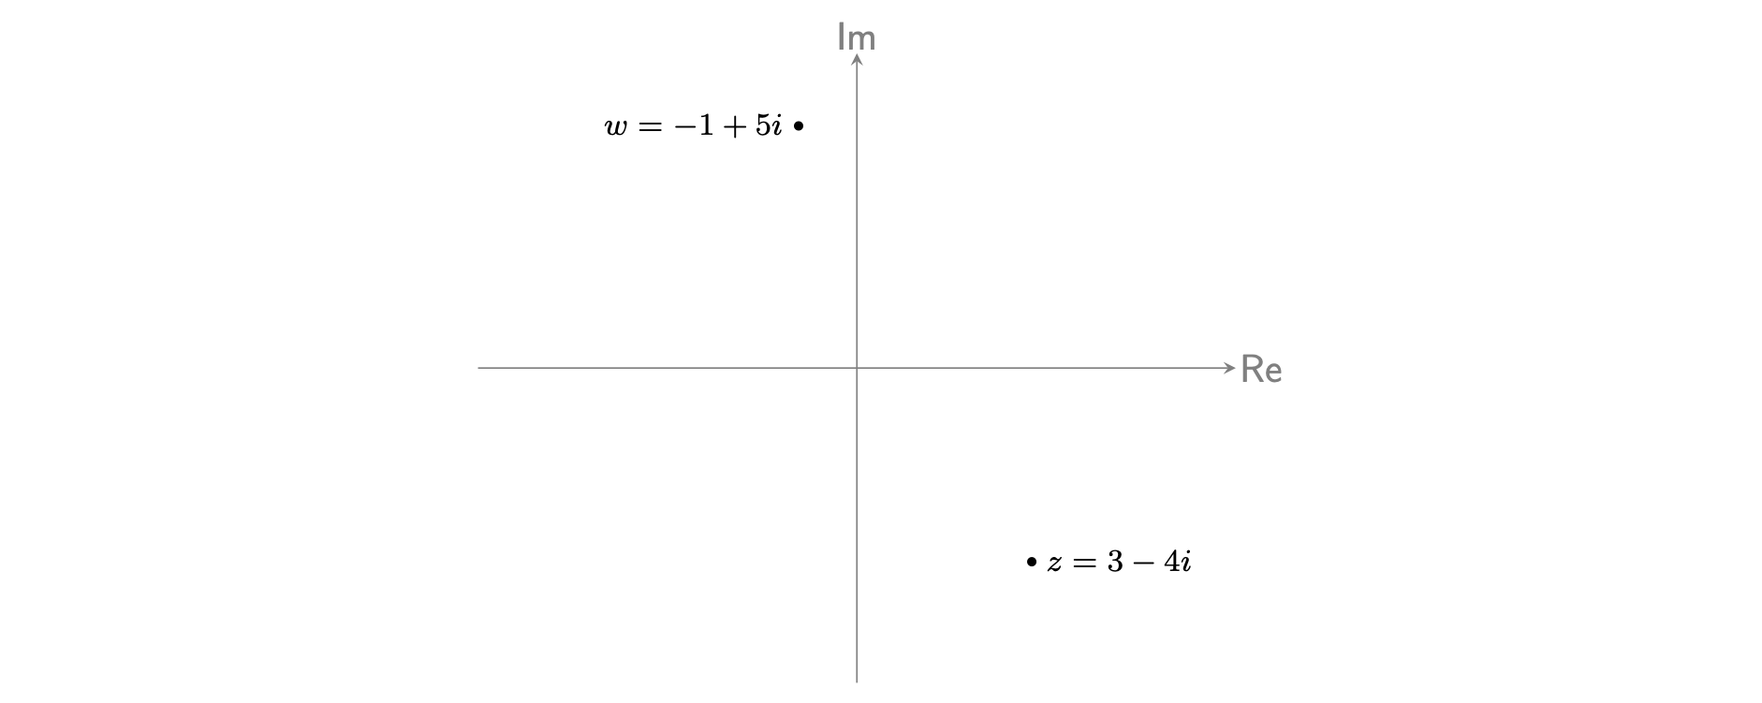
Figure 1: An Argand diagram with two complex numbers: $−1+5i$ and $3−4i$ displayed.
You can visualize the addition/subtraction of $3−4i$ and $−1+5i$. Start at the point $−1+5i$ in Figure 1. If you add $3−4i$, you are adding $3$ to the real part and $−4$ to the imaginary part. This means that you move the point $3$ units to the right and $4$ units down. If you subtract, then then you will move these in opposite directions. Where is your new point going to be on Figure 1? The answer $z+w$ is given in Figure 2.
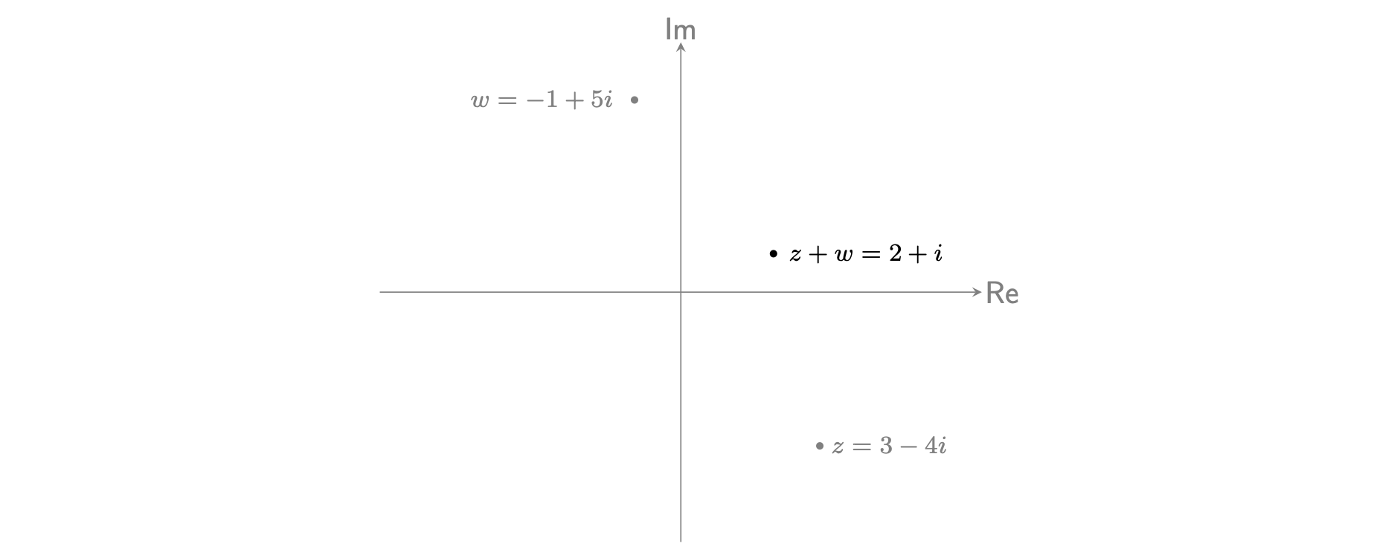
Figure 2: An Argand diagram with two complex numbers: $w=−1+5i$ and $z=3−4i$ displayed alongside the point generated by adding these two complex numbers together: $z+w=2+i$.

Multiplication
In this section, you will learn how to multiply complex numbers together. You can do this by expanding the brackets and using the fact that $i^{2}=−1$. (For more information on this please see [Guide: Introduction to expanding brackets]).
If you want to calculate $zw$ then you could write
$$zw=\left(a+bi\right)\left(c+di\right)=ac+adi+bci+bdi^{2}$$
Now you use $i^{2}=−1$ to simplify this expression:
$$zw=ac+adi+bci−bd=\left(ac−bd\right)+\left(ad+bc\right)i$$
So this is the general form; in practice, it is best to expand brackets each time as this expands upon a skill central to other areas of mathematics.
Here are some examples of multiplying complex numbers.
Example 4
What is $\left(5−7i\right)⋅\left(2+i\right)$?
Expanding the brackets gives
$$\left(5−7i\right)⋅\left(2+i\right)=10+5i−14i−7i^{2}$$
Taking care of the sign, you can use $i^{2}=−1$ to simplify this expression:
$$10+5i−14i−7i^{2}=10+5i−14i+7$$
Collecting together real and imaginary terms gives
$$\left(5−7i\right)⋅\left(2+i\right)=10+5i−14i+7=17−9i$$
Therefore, $\left(5−7i\right)⋅\left(2+i\right)=17−9i$

Example 5
What is $\left(2+i\sqrt{3}\right)⋅\left(1−i\sqrt{2}\right)$?
Using the laws of indices to simplify the square roots, you can say
$$\left(2+i\sqrt{3}\right)⋅\left(1−i\sqrt{2}\right)=2−i2\sqrt{2}+i\sqrt{3}−i^{2}\sqrt{6}$$
Here you can use $i^{2}=−1$ (taking care of signs!) to simplify this expression:
$$\left(2+i\sqrt{3}\right)⋅\left(1−i\sqrt{2}\right)=2−i2\sqrt{2}+i\sqrt{3}−i^{2}\sqrt{6}=2−i2\sqrt{2}+i\sqrt{3}+\sqrt{6}$$
and collecting together real and imaginary terms gives
$$2−i2\sqrt{2}+i\sqrt{3}+\sqrt{6}=\left(2+\sqrt{6}\right)+\left(\sqrt{3}−2\sqrt{2}\right)i$$
Therefore, $\left(2+i\sqrt{3}\right)⋅\left(1−i\sqrt{2}\right)=\left(2+\sqrt{6}\right)+\left(\sqrt{3}−2\sqrt{2}\right)i$

Example 6
What is $\left(5+3i\right)⋅\left(5−3i\right)$?
Multiplying out the brackets gives
$$\left(5+3i\right)⋅\left(5−3i\right)=25−15i+15i−9i^{2}$$
Here you can see that $−15i+15i=0$, therefore you are left with:
$$\left(5+3i\right)⋅\left(5−3i\right)=25−9i^{2}$$
Now you can use the fact that $i^{2}=−1$ to simplify this expression to give:
$$25−9i^{2}=25+9=34$$
Therefore, $\left(5+3i\right)⋅\left(5−3i\right)=34$.
You are left with a real number which might seem strange because you multiplied two complex numbers together. However, you can see that $5−3i$ is the complex conjugate of $5+3i$.
This leads to an important result regarding the product of a complex number and its complex conjugate.
Important
When you multiply any two complex conjugates together, the result is a real number (see Example 6). Consider the complex number $z=a+bi$; the complex conjugate of $z$ is $\overset{‾}{z}=a−bi$. (Please see Guide: Introduction to complex numbers for further information on complex conjugates.)
What happens if you multiply these complex numbers together?
$$\left(a+bi\right)\left(a−bi\right)=a^{2}−abi+abi−bi^{2}=a^{2}−bi^{2}=a^{2}+b^{2}$$
The key takeaway from this is
$$\left(a+bi\right)\left(a−bi\right)=a^{2}+b^{2}$$
and this is a result that you should remember.
Feel free to try this out yourself with any two complex conjugates you can think of!
There is one other special case of note when multiplying two complex numbers together.
Note
If you are multiplying a complex number by a real number, you can multiply the real part and the imaginary part by this number.
For example, if $p$ is a real number then:
$$p\left(a+bi\right)=pa+pbi.$$
Consider the point $z=3−4i$ from Figure 1 which is plotted again on Figure 3.
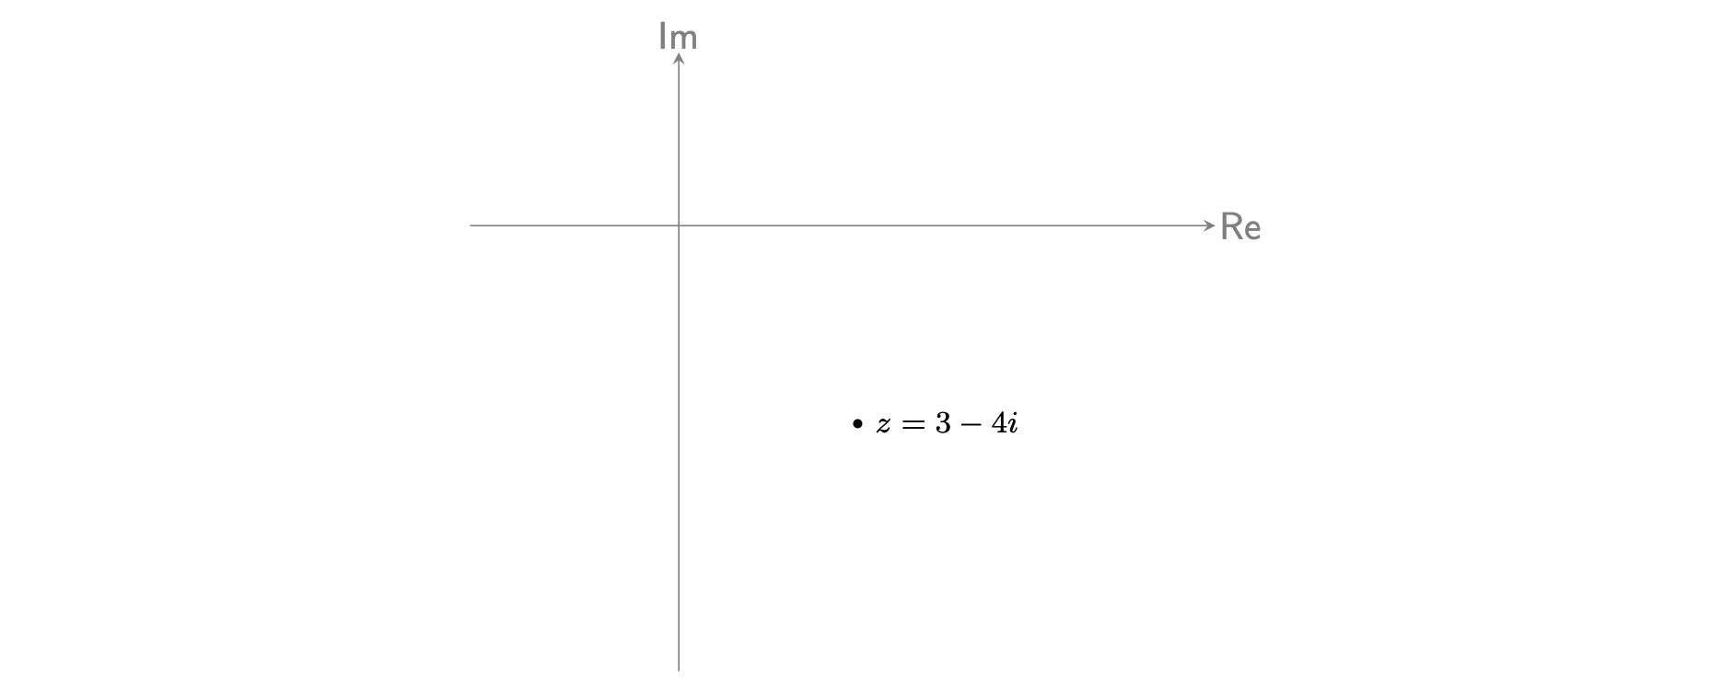
Figure 3: An Argand diagram with the complex number: $3−4i$ displayed.
Visualize the result of $2\left(3−4i\right)$. What does it mean to multiply a complex number by a real number?
$$2\left(3−4i\right)=6−8i$$
Where is this point in relation to Figure 3? The answer is given in Figure 4.
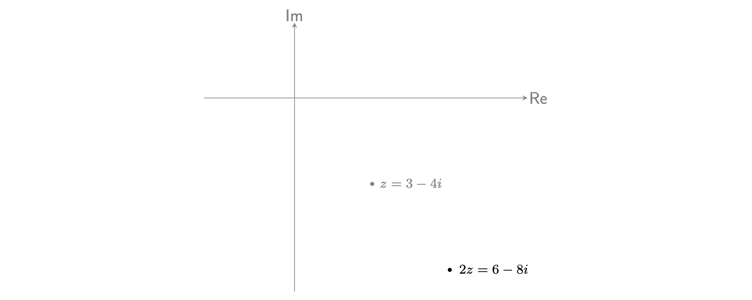
Figure 4: An Argand diagram with the complex numbers: $z=3−4i$ and the product $2\left(3−4i\right)=6−8i$ displayed.
Notice that by multiplying $z=3−4i$ by $2$ you have scaled both the real and the imaginary parts by $2$. Visually, this means the point $z=3−4i$ has been stretched outwards, away from the origin. So multiplying a complex number by a real number ‘scales’ the line connecting the complex number to $0$.
Note
Whereas multiplying a complex number by a real number gives a scaling effect, multiplying two complex numbers together gives a transformation by both scaling and rotation. The reason for this is due to the deep relationship between complex numbers and trigonometry. See [Guide: Modulus-argument form for complex numbers] for more.

Division
Dividing two complex numbers requires a little more thought. Suppose you have two complex numbers $z=a+bi$ and $w=c+di$. How would you work out
$$\frac{z}{w}=\frac{a+bi}{c+di}$$
to give an answer in the form $x+yi$?
You know how to divide by a non-zero real number, so can you manipulate this expression to get a real number in the denominator? The idea is to use the complex conjugate, which you have seen in Guide: Introduction to complex numbers, to ensure the denominator is a real number.
You know from the result after Example 6 that $\left(c+di\right)\left(c−di\right)=c^{2}+d^{2}$, so this will ensure the real number in the denominator. This needs to be introduced without changing the value of the fraction, so what you will need to do is multiply top and bottom of the fraction by the complex conjugate of the bottom. (This is the same as multiplying by $1$.) Doing this gives
$$\frac{a+bi}{c+di}=\frac{a+bi}{c+di}⋅\frac{c−di}{c−di}=\frac{\left(a+bi\right)\left(c−di\right)}{\left(c+di\right)\left(c−di\right)}$$

The denominator simplifies to $c^{2}+d^{2}$, so
$$\frac{a+bi}{c+di}=\frac{a+bi}{c+di}⋅\frac{c−di}{c−di}=\frac{\left(a+bi\right)\left(c−di\right)}{c^{2}+d^{2}}$$
You can then work out the numerator by multiplying the complex numbers as above, to get
$$\frac{z}{w}=\frac{a+bi}{c+di}=\frac{\left(ac+bd\right)+\left(bc−ad\right)i}{c^{2}+d^{2}}$$
as a final answer. Once again, it’s not about memorising the final answer, but understanding the process needed to get to this stage. To divide a complex number, multiply top and bottom by the complex conjugate of the bottom, then simplify accordingly. Here are some examples:
Example 7
What is $\frac{1}{5−2i}$ in the form $x+yi$?
The complex conjugate of $5−2i$ is $5+2i$. Therefore you can multiply $\frac{1}{5−2i}$ by $\frac{5+2i}{5+2i}$ to get:
$$\frac{1}{5−2i}=\frac{1}{5−2i}⋅\frac{5+2i}{5+2i}=\frac{5+2i}{\left(5−2i\right)\left(5+2i\right)}$$
You know that $\left(5+2i\right)\left(5−2i\right)=5^{2}+2^{2}=29$, so
$$\frac{1}{5−2i}=\frac{5+2i}{29}=\frac{5}{29}+\frac{2}{29}i$$
and this is your final answer. You could also write
$$\frac{1}{5+2i}=\frac{1}{29}\left(5+2i\right)=\frac{5+2i}{29}$$
as your final answers as well.

Example 8
What is $\frac{1−i}{2+i}$?
The complex conjugate of $2+i$ is $2−i$. Therefore you can multiply $\frac{1−i}{2+i}$ by $\frac{2−i}{2−i}$ to get
$$\frac{1−i}{2+i}=\frac{1−i}{2+i}⋅\frac{2−i}{2−i}=\frac{\left(1−i\right)\left(2−i\right)}{\left(2+i\right)\left(2−i\right)}$$
Using the key result from after Example 6, you can say that $\left(2+i\right)\left(2−i\right)=2^{2}+1^{2}=5$ and so
$$\frac{\left(1−i\right)\left(2−i\right)}{\left(2+i\right)\left(2−i\right)}=\frac{\left(1−i\right)\left(2−i\right)}{5}$$
You can now take the factor of $1/5$ out and multiply out the numerator to get
$$\frac{\left(1−i\right)\left(2−i\right)}{5}=\frac{1}{5}\left(2−i−2i+i^{2}\right)=\frac{1}{5}\left(1−3i\right)$$
and so your final answer is $\frac{1−i}{2+i}=\frac{1}{5}\left(1−3i\right)$.

Example 9
What is $\frac{2−4i}{\sqrt{3}+i}$?
The complex conjugate of $\sqrt{3}+i$ is $\sqrt{3}−i$. Therefore you can multiply $\frac{2−4i}{\sqrt{3}+i}$ by $\frac{\sqrt{3}−i}{\sqrt{3}−i}$ to get
$$\frac{2−4i}{\sqrt{3}+i}=\frac{2−4i}{\sqrt{3}+i}⋅\frac{\sqrt{3}−i}{\sqrt{3}−i}=\frac{\left(2−4i\right)\left(\sqrt{3}−i\right)}{\left(\sqrt{3}+i\right)\left(\sqrt{3}−i\right)}$$
Using the key result from after Example 6, you can say that
$$\left(\sqrt{3}+i\right)\left(\sqrt{3}−i\right)={\left(\sqrt{3}\right)}^{2}+1^{2}=3+1=4$$
and so
$$\frac{\left(2−4i\right)\left(\sqrt{3}−i\right)}{\left(\sqrt{3}+i\right)\left(\sqrt{3}−i\right)}=\frac{\left(2−4i\right)\left(\sqrt{3}−i\right)}{4}$$
You can now take the factor of $1/4$ out and multiply out the numerator to get
$$\frac{\left(2−4i\right)\left(\sqrt{3}−i\right)}{4}=\frac{1}{4}\left(2\sqrt{3}−2i−i4\sqrt{3}−4\right)=\frac{1}{4}\left(\left(2\sqrt{3}−4\right)−\left(2+4\sqrt{3}\right)i\right)$$
This is an acceptable final answer; or if you wanted to, you could take out a factor of $2$ and write
$$\frac{2−4i}{\sqrt{3}+i}=\frac{1}{2}\left(\left(\sqrt{3}−2\right)−\left(1+2\sqrt{3}\right)i\right)$$

Quick check problems
- Work out the following arithmetic questions, giving your answers in the form $a+bi$ where $a$ is the real part and $b$ is the imaginary part. If your answer is a fraction please write it in decimal form.
- What is $\left(−4−i\right)−\left(7−6i\right)$?
- What is $\left(3−4i\right)+\left(−2−9i\right)−\left(6+4i\right)$?
- What is ${\left(3−4i\right)}^{2}$?
- What is $\left(7−i\right)\left(4+6i\right)$?
- What is $\frac{6−i}{−5i}$?
- Determine whether the following statements are true or false:
- Multiplying together $\left(2−2i\right)$ and $\left(2+2i\right)$ will give you a real number.
- The real part of the answer to the sum $\left(−4−5i\right)−\left(−6\sqrt{2}−i\right)$ is negative.

Further reading
To find out more about what happens when two complex numbers are multiplied (and much more), please see [Guide: Modulus-argument form of complex numbers].
For more questions on the subject, please go to Questions: Arithmetic on complex numbers.

Version history and licensing
v1.0: initial version created 11/24 by Charlotte McCarthy as part of a University of St Andrews VIP project.
This work is licensed under CC BY-NC-SA 4.0.

