Questions: Introduction to fractions
Donald Campbell
Summary
A selection of questions for the study guide on the introduction to fractions.
Before attempting these questions, it is highly recommended that you read Guide: Introduction to numerical fractions.

Q1
For each figure, write the fraction that represents the shaded area.
1.1. 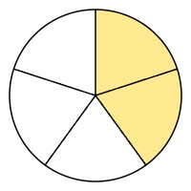
1.2. 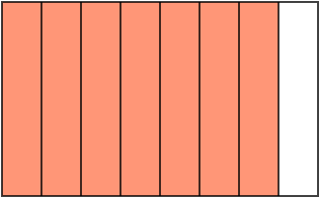
1.3. 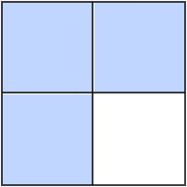
1.4. 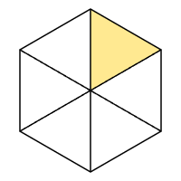
1.5. 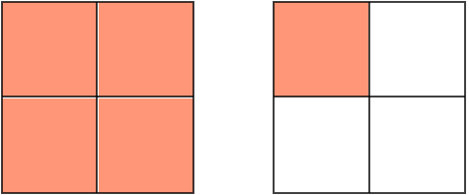
1.6. 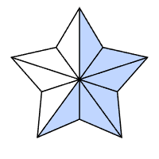
1.7. 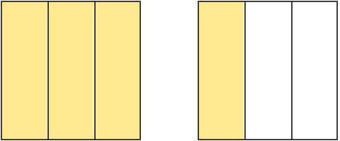
1.8. 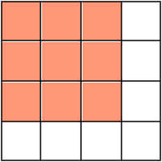
1.9. 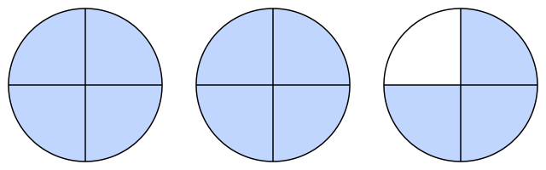
1.10. 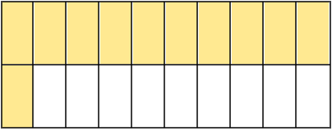

Q2
Convert each mixed number into an improper fraction.
2.1. $1\frac{1}{2}$
2.2. $−2\frac{2}{3}$
2.3. $3\frac{1}{4}$
2.4. $−5\frac{2}{5}$
2.5. $4\frac{3}{7}$
2.6. $6\frac{1}{6}$
2.7. $−8\frac{3}{5}$
2.8. $10\frac{2}{9}$
2.9. $−7\frac{5}{11}$
2.10. $12\frac{3}{4}$

Q3
Convert each improper fraction into a mixed number.
3.1. $\frac{5}{2}$
3.2. $−\frac{7}{4}$
3.3. $\frac{10}{3}$
3.4. $\frac{−11}{7}$
3.5. $\frac{12}{6}$
3.6. $−\frac{25}{6}$
3.7. $\frac{31}{9}$
3.8. $\frac{50}{11}$
3.9. $\frac{64}{−8}$
3.10. $−\frac{100}{13}$

Q4
Find the missing value $?$ that makes the two fractions equivalent.
4.1. $\frac{1}{4}=\frac{?}{12}$
4.2. $\frac{2}{3}=\frac{6}{?}$
4.3. $\frac{3}{5}=\frac{?}{25}$
4.4. $\frac{5}{8}=\frac{?}{16}$
4.5. $\frac{3}{4}=\frac{?}{−20}$
4.6. $−\frac{1}{6}=\frac{?}{24}$
4.7. $\frac{5}{8}=\frac{20}{?}$
4.8. $\frac{4}{3}=\frac{?}{18}$
4.9. $−\frac{1}{3}=\frac{?}{27}$
4.10. $\frac{7}{10}=\frac{70}{?}$
4.11. $−\frac{4}{5}=\frac{?}{30}$
4.12. $\frac{11}{12}=\frac{?}{60}$
4.13. $\frac{3}{−7}=\frac{?}{21}$
4.14. $\frac{8}{9}=\frac{32}{?}$
4.15. $\frac{6}{7}=−\frac{?}{−49}$

Q5
Write each fraction in its simplest form.
5.1. $\frac{4}{8}$
5.2. $\frac{3}{9}$
5.3. $\frac{6}{10}$
5.4. $\frac{9}{12}$
5.5. $\frac{15}{25}$
5.6. $\frac{7}{21}$
5.7. $\frac{20}{30}$
5.8. $\frac{35}{49}$
5.9. $\frac{48}{72}$
5.10. $\frac{100}{120}$

Q6
Convert each fraction into its alternative form and fully simplify the result.
- If an improper fraction is given, convert it into a mixed number.
- If a mixed number is given, convert it into an improper fraction.
6.1. $\frac{6}{4}$
6.2. $2\frac{2}{8}$
6.3. $\frac{12}{10}$
6.4. $−\frac{15}{9}$
6.5. $3\frac{4}{6}$
6.6. $−1\frac{6}{8}$
6.7. $\frac{20}{12}$
6.8. $\frac{30}{25}$
6.9. $5\frac{10}{15}$
6.10. $−\frac{45}{20}$
6.11. $4\frac{8}{10}$
6.12. $\frac{50}{30}$
6.13. $\frac{75}{−50}$
6.14. $6\frac{12}{16}$
6.15. $−2\frac{14}{21}$

After attempting the questions above, please click this link to find the answers.

Version history and licensing
v1.0: initial version created 12/25 by Donald Campbell as part of a University of St Andrews VIP project.
This work is licensed under CC BY-NC-SA 4.0.

