Making it count: an introduction to the theory of functions
Tom Coleman
Summary
In the third of four linked presentations, this session takes the material covered in the previous two sessions and looks at it from a more general perspective by introducing the theory of functions. Along the way, you’ll learn why and how you use functions in everyday life, how every sequence of numbers is a function in disguise, and why pigeons are so important in mathematics.

The function junction
 Try it yourself 1
How many elements are in this set?
$$X=\{a,1,2,3,b,5,193,14555,c,p,23,L,Q,W,A\}$$

 Answer to try it yourself 1
There are $14$, but that’s not important. Read on…

The important thing was how you counted it. If you counted out loud, you probably said $1,2,3,4,…$ all the way up to $14$, pointing at each element in turn. This is how you are first taught to count things.
In fact, what you are doing is taking an input from $X$ and assigning it an output from the set of all positive whole numbers. This linking of an input to an output is the idea of a mathematical function.
Function, domain, range
Let $X,Y$ be two sets.
A function $f$ from the set $X$ to the set $Y$ is an assignment that maps each element of $X$ to exactly one output in $Y$. It is written as $f:X→Y$, and the notation $f(x)=y$ means ’$f$ maps $x∈X$ to $y∈Y$.
Here, the set $X$ is called the domain of $f$ and the set $Y$ is called the codomain of $f$.
Two functions $f$ and $g$ are equal if and only if they have the same domain $X$, codomain $Y$, and $f(x)=g(x)$ for all $x∈X$.

The important thing is that for some $x∈X$, there is exactly one $y∈Y$ such that $f(x)=y$ - so one element of $X$ can’t map to many elements of $Y$. The converse is not true; many elements of $X$ are allowed to one element of $Y$.
Here are some examples of functions.
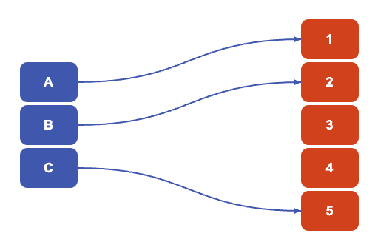
This is an example of a function. You can notice each element of the domain $\{A,B,C\}$ on the left is mapped to exactly one element in the codomain $\{1,2,3,4,5\}$ on the right. $A$ is mapped to $1$, $B$ is mapped to $2$, and $C$ is mapped to $5$.
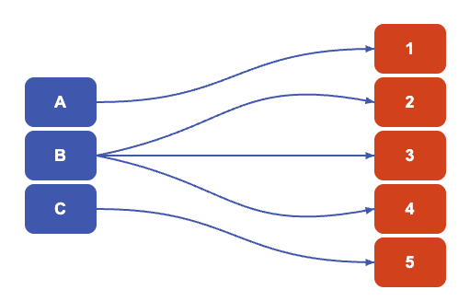
This is an example of something that isn’t a function, because it shows ‘one-to-many’ behaviour. The element $B$ can only be mapped to one element in a function, but here it is mapped to three elements $2,3,4$.
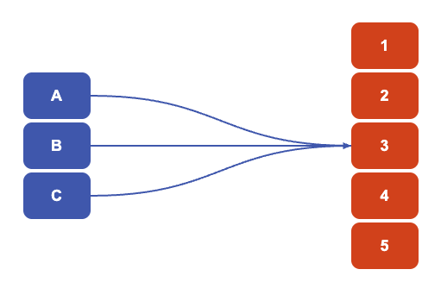
This is an example of a function showing ‘many-to-one’ behaviour. You can notice each element of the domain $\{A,B,C\}$ on the left is mapped to exactly one element in the codomain $\{1,2,3,4,5\}$ on the right. All elements of the domain are mapped to $3$.
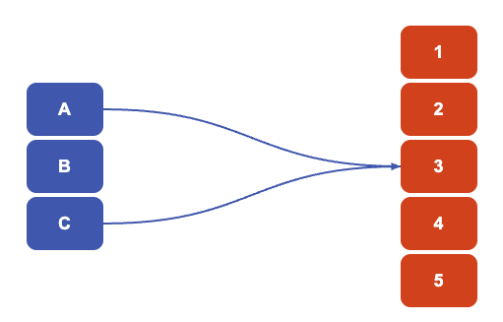
This is an example of something that isn’t a function. Not every element of the domain $\{A,B,C\}$ is mapped to an element of the codomain. To turn this into a function, you will need to decide where $B$ is mapped to.

Sequences
In mathematics, the reason why functions are incredibly powerful is because they allow for comparison between sets. Any time you want to compare two sets - a function is almost always used. Any time you want to look at growth, or rates of change, or to decide behaviour in the future: you will use a function.
One of the ways that functions are studied in mathematics is the idea of a sequence. You saw all about sequences in Exploration: The hidden sequences of Pascal’s triangle; how they can be either finite or infinite, how they could have formulas or not.
In fact, every sequence is a function in disguise. To help illustrate this, here is some new mathematical notation; this is a common thing to do in mathematics to help explain certain concepts.
Special notation for sets
Write $[n]$ to be the set $\{1,2,3,…,n\}$ of all positive whole numbers from $1$ up to $n$ included. So $[4]=\{1,2,3,4\}$ and $[k]=\{1,2,3,…,k\}$. You can notice that the number of elements of $[n]$ is $n$
For the (infinite) set of all positive whole numbers, write
$$N=\{1,2,3,…\}$$
as the set of natural numbers. You can write
$$N_{0}=\{0,1,2,3,…\}$$
to be the set of natural numbers with zero.
For the (infinite) set of all possible numbers - whole, fractions and decimals, positive and negative - write $R$ to be the set of these numbers (called real numbers).

This makes it a lot easier to phrase the following important consideration:
Sequences and functions
- Any finite sequence of length $n$ of symbols from the set $[k]$ can be viewed as a function $f:[n]→[k]$.
- In the reverse direction, any function $f:[n]→[k]$ is a finite sequence of length $n$ of symbols from the set $[k]$
- Any finite sequence of numbers of length $n$ can be viewed as a function $f:[n]→R$.
- Any infinite sequence of numbers can be viewed as a function $f:N→R$, and any function $f:N→R$ can be written as an infinite sequence.

Try it yourself 2
Why are (a) and (b) true? As an initial pointer, think about where the set $[n]$ will appear in your consideration.

Answer to try it yourself 2
For (a), suppose that you have a sequence of length $n$ of elements from $[k]$; you could say that this is
$$a_{1},a_{2},…,a_{n}.$$
You can see that for every number $i$ between $1$ and $n$, there is an element $a_{i}$ of $[k]$ at position $i$ in the list. You can then define a function $f:[n]→[k]$ by the assignment
$$f(i)=a_{i}$$
which sends $i∈[n]$ to $a_{i}$. This then determines the sequence $a_{1},a_{2},…,a_{n}$.
For (b), suppose you have a function $f:[n]→[k]$. You can now view this as a sequence of length $n$ in $[k]$ by writing out all of the outputs in order:
$$f(1),f(2),…,f(n)$$
which defines a finite sequence of length $n$ with elements in $[k]$.

Parts (c) and (d) follow from similar reasoning.
This means that finite/infinite sequences can be studied through functions.
Examples of sequences as functions
If a sequence has a closed form formula, then it can be represented concisely as a function. For instance, the sequence of cube numbers can be written as $f_{1}:N→N$ with $f(n)=n^{3}$, or the powers of two as $f_{2}:N_{0}→N$ with $f_{2}(n)=2^{n}$. Even constant sequences can be written as functions: write $f_{3}:N→\{153\}$ to be $f_{3}(n)=153$ for all $n∈N$.
The binomial coefficients can also be written as a function, but the domain needs to be all pairs of all whole numbers with $0$. Write
$$N_{0}×N_{0} =\{(n,k) : n,k∈N_{0}\}.$$
Then the binomial coefficient can be written as a function $b:N_{0}×N_{0}×N$ with
$$b(n,k)=\left({n \atop k}\right).$$

Here’s an excellent result that follows from this.
Counting number of functions
The total number of possible functions $f:[n]→[k]$ is $k^{n}$.

Proof of the formula of the number of functions
You are given that $[n]=\{1,2,3,…,n\}$, and there is a function $f:[n]→[k]$. Write $f$ as a finite sequence of length $n$ with elements from $k$ to get
$$f(1),f(2),f(3),…,f(n)$$
So, you can ask yourself - what is $f(1)$? Well, you don’t know, as you aren’t given the information. However, there are $k$ many choices for the value of $f(1)$, because it has to be exactly one element of the set $[k]=\{1,2,3,…,k\}$. Since it can be any of them, this gives $k$ choices.
Next, you can ask - what is $f(2)$? Again, there are $k$ many choices. You can notice here that the choice of the value of $f(2)$ is completely independent of the choice for the value of $f(1)$. Similarly, there are $k$ many choices for the value of $f(3)$ and this choice is independent of the values of $f(1)$ and $f(2)$.
You can carry on in this way for all the elements of $[n]$. With $k$ choices for each element, and all of the choices being independent of each other, this leads to
$$\underset{\text{what is }f(1)?}{\underset{⏟}{k}}⋅\underset{\text{what is }f(2)?}{\underset{⏟}{k}}⋅\underset{\text{what is }f(3)?}{\underset{⏟}{k}}⋅…⋅\underset{\text{what is }f(n)?}{\underset{⏟}{k}}=k^{n}$$
many choices for the sequence $f(1),f(2),f(3),…,f(k)$. Therefore, there are $k^{n}$ possible functions $f:[n]→[k]$.

Try it yourself 3
Does this seem familiar?

Note
This is an almost a word-for-word recreation of the proof in Exploration: How to win at cards - combinations and permutations that there were $2^{n}$ many subsets of a set $\{1,2,3,…,n\}$!
So what’s happening here? Well, the idea of deciding whether or not each element of $[n]=\{1,2,3,…,n\}$ is in some subset of $[n]$ can be modelled as a function $f:[n]→[2]$, where $f(i)=1$ says that $i$ is not in the subset, and $f(i)=2$ says that $i$ is in the subset. Therefore, every function $f:[n]→[2]$ corresponds to a subset of $[n]$, and every subset of $[n]$ corresponds to a function $f:[n]→[2]$. This function is called an indicator function for the subset of $[n]$.

Injective, surjective, bijective
Now, much like numbers can be odd, even, prime, not prime, and so on, functions have different properties as well. To do this, you’ll need to examine exactly where the function sends its elements.
Image of a function
The set
$$f(X)=\{f(x)\text{ where }x∈X\}⊆Y$$
is called the image of $f$. It follows from this that the image of $f$ is a subset of the codomain $Y$ of $f$.

Here are some examples of images of functions.
In this function $A$ is mapped to $1$, $B$ is mapped to $2$, and $C$ is mapped to $5$, so the image of this function is $\{1,2,5\}$.
As everything in the domain $\{A,B,C\}$ is mapped to $3$, the image of this function is the set $\{3\}$, which is a subset of the codomain $\{1,2,3,4,5\}$.
How functions map into the image is important, and how much of the codomain is covered in the image is important. Together, these properties underpin the very idea of counting.
Injective, surjective, and bijective
Suppose that $f:X→Y$ is a function from $X$ to $Y$.
- Say that $f$ is injective (or one-to-one, or even one-one) if $x_{1}≠x_{2}$ means that $f(x_{1})≠f(x_{2})$ for all $x_{1},x_{2}∈X$. Equivalently, $f$ is injective if $f(x_{1})=f(x_{2})$ implies that $x_{1}=x_{2}$ for all $x_{1},x_{2}∈X$.
- Say that $f$ is surjective (or onto) if for all $y∈Y$ there exists $x∈X$ such that $f(x)=y$. Equivalently, $f$ is surjective if the image $f(X)$ of $f$ is equal to the codomain $Y$ of $f$.
- Say that $f$ is bijective if $f$ is both injective and surjective.

Intuitively, you could say that
- $f$ is injective if different elements in $A$ always map to different elements in $B$.
- $f$ is surjective if every element of $B$ has an element of $A$ that maps to it.
- $f$ is bijective if every element of $B$ has a unique element of $A$ that maps to it.
It’s important that in mathematics, you have both the precise definition and the intuition behind it - it’s like the spirit and letter of the law, they have to line up in order to be effective.
Try it yourself 4
Using the interactive function investigator above, find examples of injective, surjective and bijective functions, and write down their images. What do you notice about the sizes of the sets involved?

Answer to try it yourself 4
Here’s an example of an injective function $f:\{A,B,C\}→\{1,2,3,4,5\}$:
$$f(A)=1, f(B)=2, f(C)=5$$
with image $\{1,2,5\}$. You can notice that each of the domain elements $\{A,B,C\}$ is sent to a different element of the codomain, demonstrating that the function is injective.
A picture of the injective function in the answer to Try it yourself 4.
Here’s an example of a surjective function $g:\{A,B,C,D,E\}→\{1,2,3\}$:
$$g(A)=1, g(B)=2, g(C)=3, g(D)=1, g(E)=2$$
with image $\{1,2,3\}$. Since the image $\{1,2,3\}$ is the same as the codomain, it follows that this function is surjective.
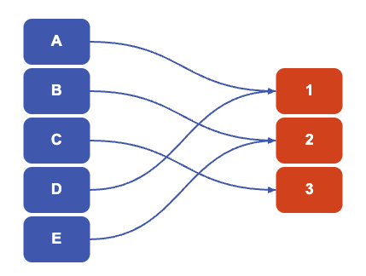
A picture of the surjective function in the answer to Try it yourself 4.
Here’s an example of a bijective function $h:\{A,B,C\}→\{1,2,3\}$:
$$h(A)=1, h(B)=2, h(C)=3$$
with image $\{1,2,3\}$. You can notice that each of the domain elements $\{A,B,C\}$ is sent to a different element of the codomain, demonstrating that the function is injective - in addition, the image $\{1,2,3\}$ is the same as the codomain, so the function is also surjective. This means that $h$ is bijective.
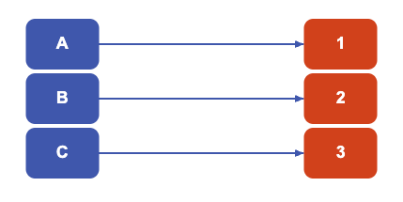
A picture of the bijective function in the answer to Try it yourself 4.

What about the functions before?
Previous examples
- The function $f_{1}:N→N$ with $f_{1}(n)=n^{3}$ is injective but not surjective. For injective, you need to take two potential equal ouputs and show they come from the same input. So if $f_{1}(x)=f_{1}(y)$ then $x^{3}=y^{3}$, and so $x=y$ - therefore, $f_{1}$ is injective. To show that $f_{1}$ is not surjective, it’s enough to show that there is an element of the codomain that isn’t in the image; since there is no natural number that cubes to make $2$, it follows that $2$ is not in the image. So $f_{1}$ is not surjective.
- Similarly, $f_{2}:N_{0}→N$ with $f_{2}(n)=2^{n}$ is injective but not surjective.
- The function $f_{3}:N→\{153\}$ with $f_{3}(n)=153$ for all $n∈N$ is surjective but not injective. Here, the image of $f_{3}$ is $\{153\}$ which is the same as the codomain, so $f_{3}$ is surjective. To show that it’s not injective, you can notice that $f_{3}$ sends both $1$ and $2$ to $153$ and since $1≠2$, different elements aren’t always mapped to different elements and the function is not injective.
- The binomial coefficient written as a function $b:N_{0}×N_{0}×N$ with
$$b(n,k)=\left({n \atop k}\right)$$
- is surjective but not injective. For surjective, suppose that $m$ is in $N$; you need to find a pair $(n,k)$ such that $b(n,k)=m$. Since $\left({m \atop 1}\right)=m$ for all $m$ in $N$, it follows that taking $n=m$ and $k=1$ shows that every $m∈N$ is in the image of $b$. So $b$ is surjective. However, $b$ is not injective as
$$b(3,1)=\left({3 \atop 1}\right)=3=\left({3 \atop 2}\right)=b(3,2)$$
- but the inputs $(3,1)$ and $(3,2)$ are not the same.

You can also notice that
- if a function is surjective, then the cardinality of the domain $X$ is greater than or equal to the cardinality of the codomain $Y$, so $|X|≥|Y|$.
- if a function is injective, then the cardinality of the codomain $Y$ is greater than or equal to the cardinality of the domain $Y$, so $|Y|≥|X|$.
- if a function is bijective, then the cardinality of the domain $X$ is equal to the cardinality of the domain $Y$, so $|X|=|Y|$.
These observations can be reversed using a mathematical principle called the contrapositive. This allows you to change the logical perspective of a statement ‘if $A$ then $B$’ to ‘if not $B$ then not $A$’.
Doing this to the observations above give the following statements about any function $f:X→Y$:
- if the cardinality of the domain $X$ is less than the cardinality of the codomain $Y$, then $f$ is never surjective.
- if the cardinality of the codomain $Y$ is less than the cardinality of the domain $X$, then $f$ is never injective.
- if the cardinalities of the domain $X$ and the codomain $Y$ are not equal, then $f$ is never bijective.

Pigeons
The second of these statements is equivalent to an important principle in combinatorics.
The pigeonhole principle
Suppose that $n>m$. If you have $n$ items and $m$ boxes in which to put them, then at least one box contains more than one item.

Proof of the pigeonhole principle
Give numbers to your list of items $\{1,2,3,…,n\}$. Put item $1$ in box $1$, item $2$ in box $2$, and so on until you put item $m$ in box $m$. Since $n>m$, it follows that $n−m≥1$ and so you have at least one item to put in a box. It follows that at least one box contains more than one item.

Scenario 1
Cantor’s Confectionery is one of the best places to work in the fictional world. It has the habit of throwing a birthday party for every one of its employees on their birthday, which is truly exceptional for morale. They have appointed you, its HR representative, to try and investigate cost-cutting measures for this expensive endeavour. The best way to achieve this is to have a shared party between two or more employees.
What is the number $n$ of employees required to have
- a $50\%$ chance that two employees share the same birthday?
- a $100\%$ chance that two employees share the same birthday?

The first of these is probability, and relies on techniques seen in Explorations: How to win at cards - combinations and permutations. The second uses the pigeonhole principle!
Answer to Scenario 1
For convenience, assume that there are $365$ days in the year, as there are in most years.
- Here, it’s easier to work out the probability of this not happening - you can then subtract this from $1$ to work out the probability of this happening.
Write a list of your employees. Suppose that the first employee has a birthday on any day of the year. The chances that a second employee has a different birthday than the first is $364/365$. The chances that a third employee has a different birthday than the first two is $363/365$. You can continue in this way to show that the probability that $n$ employees all have different birthdays is
$$\begin{aligned}P(\text{different birthdays})&=\frac{365}{365}⋅\frac{364}{365}⋅\frac{363}{365}⋅…⋅\frac{(365−n)}{365} \\ &=\frac{(365)_{n}}{{365}^{n}}\end{aligned}$$
where $(365)_{n}$ is the falling factorial from Explorations: How to win at cards - combinations and permutations.
As it turns out, the number $n$ that tips this number below $50\%$ - and so the chances that two employees share a birthday is above $50\%$ - is $n=23$. So for a company with $23$ employees, there is a greater than $50\%$ chance that two employees share a birthday!
- Here, the worst-case scenario is that everybody has a different birthday. Since there are $365$ possible birthdays, the worst case scenario is that the company has $365$ employees, each with different birthdays.
So if there are $366$ employees in Cantor’s Confectionery, then it’s guaranteed that at least two people share a single birthday. So the answer is $n=366$.

The pigeonhole principle also guarantees that in Scotland, at least two people have the same numbers of hairs on their head!

Counting blessings
So what does all of this have to do with counting?
If you count the set in Try it yourself 1 by pointing at each element and saying each number, you created a bijection between the set and the set of number $\{1,2,…,14\}$. By putting sets in bijections with other sets, or not, you can directly compare them to each other by their sizes. This is infact the definition of counting:
Definition of cardinality
Let $X$ be a set, and $[n]=\{1,2,3,…,n\}$. If there exists a bijection $f:X→[n]$, then write $|X|=n$.

So finding bijections between sets of things and sets of natural numbers is the very idea of mathematically defining how to count things. It is the injective part that identifies each element of $X$ with a unique natural number, and the surjective part ensures that all the numbers in $\{1,2,3,…,n\}$ are covered.
If the surjective part doesn’t exist, then you have inequalities rather than equality. Thankfully, because of the way surjective functions are defined, you can ‘shrink’ the codomain of your function to the image to create a bijective function.
So if there exists an injective function $g:X→[n]$, then this tells you that there is a bijection $g:X→[m]$ where $m<n$. So not only do bijective functions tell you about the cardinality of sets, injective functions tell you which sets are bigger than others. The following are strengthenings of the above observations.
Injections
- If there exists an injection $f:X→Y$, then $|X|≤|Y|$.
- If there exists an injection $g:Y→X$, then $|Y|≤|X|$.
- (Cantor-Schröder-Bernstein theorem) If there exists injections $f:X→Y$ and $g:Y→X$, then $|X|=|Y|$.

Notice here that none of the sets here were specifically stated to be finite. So this idea of comparing sets using injective and bijective functions extend to where the sets are infinite - and this will have even more surprising results in the next exploration…

Version history
v1.0: initial version created 07/26 by tdhc, originally for presentation 3 of 4 for Sutton Trust Summer School 2026.
This work is licensed under CC BY-NC-SA 4.0.

