Answers: Introduction to linear regression
Flora Green
Summary
Answers to questions relating to the guide on introduction to linear regression.
These are the answers to Questions: Introduction to linear regression.
Please attempt the questions before reading these answers!

Q1
1.1. $α$ is the $y$-intercept of the regression line $E\left(Y\right)=α+βx$.
1.2. $β$ is the gradient of the regression line $E\left(Y\right)=α+βx$.

Q2
2.1. A residual is the difference between the observed value $y_{i}$ and the estimated value $E\left(Y_{i}\right)$.
2.2. It minimizes the squared sum of the residuals to find the optimal regression line for a sample of data.

Q3
3.1. Here, $\hat{α}=146.6853$.
3.2. Here, $\hat{β}=1.7044$.
3.3. $E\left(Y\right)=α+βx=\hat{α}+\hat{β}x=146.6853+1.7044x$
3.4. The $R^{2}$ coefficient of determination is $0.2691$, which suggests that the response variable is not well modelled by a linear model of the explanatory variable.
Please note that for this question, the following R code was used. It is recommended that you use Calculator: Simple linear regression or statistical software like this to do these calculations, as these can be very tedious to do by hand.
confectionery = data.frame(customers=c(43,54,65,42,68,49,
63,57,71,47,75,67),sweets=c(188,197,215,217,233,244,254,256,
274,286,291,300))
model=lm(sweets~customers,data=confectionery)
summary(model)
plot(confectionery$customers, confectionery$sweets,
pch = 19, col = "#3f68b6",
xlab = "Number of customers",
ylab = "Sweets sold")
abline(model, col = "#db4315", lwd = 2)
Code output:
Call:
lm(formula = sweets ~ customers, data = confectionery)
Residuals:
Min 1Q Median 3Q Max
-42.471 -30.181 3.121 14.471 59.208
Coefficients:
Estimate Std. Error t value Pr(>|t|)
(Intercept) 146.6853 52.7694 2.780 0.0195 *
customers 1.7044 0.8882 1.919 0.0839 .
---
Signif. codes: 0 '***' 0.001 '**' 0.01 '*' 0.05 '.' 0.1 ' ' 1
Residual standard error: 33.36 on 10 degrees of freedom
Multiple R-squared: 0.2691, Adjusted R-squared: 0.1961
F-statistic: 3.683 on 1 and 10 DF, p-value: 0.08395
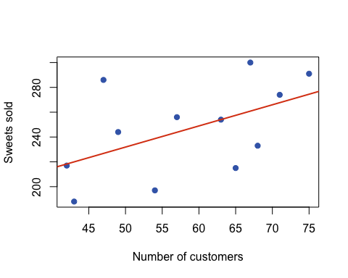

Version history and licensing
v1.0: initial version created 12/25 by Flora Green as part of a University of St Andrews VIP project.
This work is licensed under CC BY-NC-SA 4.0.

