Answers: Introduction to complex numbers
Tom Coleman
Summary
Answers to questions relating to the guide on introduction to complex numbers.
These are the answers to Questions: Introduction to complex numbers.
Please attempt the questions before reading these answers!

Q1
Using complex numbers, find solutions to the following equations.
1.1. Here, $x=i$ and $x=−i$ are the two solutions.
1.2. Here, $x=3i$ and $x=−3i$ are the two solutions.
1.3. Here, $x=12i$ and $x=−12i$ are the two solutions.
1.4. Here, $x=1$ and $x=−1$ are the two solutions. (Real numbers are complex numbers too!)

Q2
For each of the complex numbers below, give their real and imaginary parts. (In this question, $a,b$ are real numbers.)
2.1. The real part of $z_{1}$ is $\text{Re}\left(z_{1}\right)=2$ and the imaginary part of $z_{1}$ is $\text{Im}\left(z_{1}\right)=3$.
2.2. The real part of $z_{2}$ is $\text{Re}\left(z_{2}\right)=−23$ and the imaginary part of $z_{2}$ is $\text{Im}\left(z_{2}\right)=32$.
2.3. The real part of $z_{3}$ is $\text{Re}\left(z_{3}\right)=3$ and the imaginary part of $z_{3}$ is $\text{Im}\left(z_{3}\right)=−3$.
2.4. The real part of $z_{4}$ is $\text{Re}\left(z_{4}\right)=0$ and the imaginary part of $z_{4}$ is $\text{Im}\left(z_{4}\right)=3$.
2.5. The real part of $z_{5}$ is $\text{Re}\left(z_{5}\right)=−3$ and the imaginary part of $z_{5}$ is $\text{Im}\left(z_{5}\right)=−2$.
2.6. The real part of $z_{6}$ is $\text{Re}\left(z_{6}\right)=a$ and the imaginary part of $z_{6}$ is $\text{Im}\left(z_{6}\right)=2b$.
2.7. The real part of $z_{7}$ is $\text{Re}\left(z_{7}\right)=2$ and the imaginary part of $z_{7}$ is $\text{Im}\left(z_{7}\right)=0$.
2.8. The real part of $z_{8}$ is $\text{Re}\left(z_{8}\right)=3/2$ and the imaginary part of $z_{8}$ is $\text{Im}\left(z_{8}\right)=2/3$.
2.9. The real part of $z_{9}$ is $\text{Re}\left(z_{9}\right)=22$ and the imaginary part of $z_{9}$ is $\text{Im}\left(z_{9}\right)=−33$.
2.10. The real part of $z_{10}$ is $\text{Re}\left(z_{10}\right)=333$ and the imaginary part of $z_{10}$ is $\text{Im}\left(z_{10}\right)=22$.
2.11. The real part of $z_{11}$ is $\text{Re}\left(z_{11}\right)=−2$ and the imaginary part of $z_{11}$ is $\text{Im}\left(z_{11}\right)=2$.
2.12. The real part of $z_{12}$ is $\text{Re}\left(z_{12}\right)=−2$ and the imaginary part of $z_{11}$ is $\text{Im}\left(z_{11}\right)=−3$.

Q3
The complex conjugate of $z_{1}=2+3i$ is ${\overset{‾}{z}}_{1}=2−3i$.
The complex conjugate of $z_{2}=−23+32i$ is ${\overset{‾}{z}}_{2}=−23−32i$.
The complex conjugate of $z_{3}=3−3i$ is ${\overset{‾}{z}}_{3}=3+3i$.
The complex conjugate of $z_{4}=3i$ is ${\overset{‾}{z}}_{4}=−3i$.
The complex conjugate of $z_{5}=−3−2i$ is ${\overset{‾}{z}}_{5}=−3+2i$.
The complex conjugate of $z_{6}=a+2bi$ is ${\overset{‾}{z}}_{6}=a−2bi$.
The complex conjugate of $z_{7}=2$ is ${\overset{‾}{z}}_{7}=2$.
The complex conjugate of $z_{8}=3/2+2i/3$ is ${\overset{‾}{z}}_{8}=3/2−2i/3$.
The complex conjugate of $z_{9}=22−33i$ is ${\overset{‾}{z}}_{9}=22+33i$.
The complex conjugate of $z_{10}=333+22i$ is ${\overset{‾}{z}}_{10}=333+22i$.
The complex conjugate of $z_{11}=2i−2$ is ${\overset{‾}{z}}_{11}=−2i−2$.
The complex conjugate of $z_{12}=−3i−2$ is ${\overset{‾}{z}}_{12}=3i−2$.

Q4
See Figure 1 for the Argand diagram. You can notice that the complex conjugates of the complex numbers can be obtained by reflecting the point in the real axis.
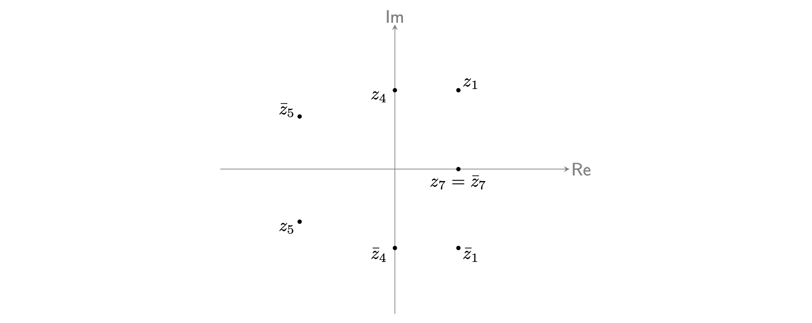
Figure 1: An Argand diagram with the seven complex numbers $z_{1},{\overset{‾}{z}}_{1},z_{4},{\overset{‾}{z}}_{4},$ in Example 5.

Version history and licensing
v1.0: initial version created 10/24 by tdhc.
This work is licensed under CC BY-NC-SA 4.0.

